

**AP Calculus BC**

Q1 Interim Assessment

Test Booklet 1

Multiple Choice - Non-Calc

October 2017

School: _____________________________________________

Student Name: _____________________________________________

Teacher: _____________________________________________

Period: _____________________________________________

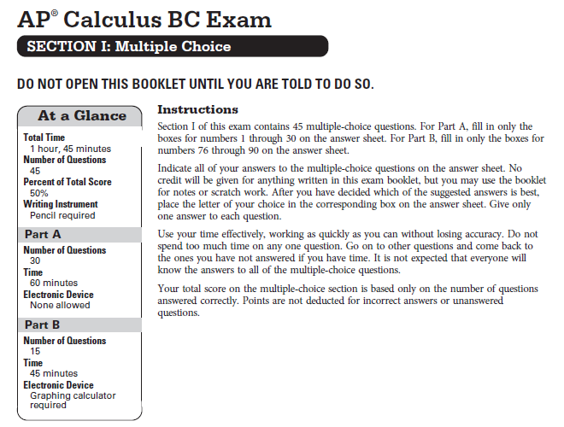

**CALCULUS BC**

**SECTION I, Part A**

**Time – 60 minutes**

**Number of questions – 30**

**NO CALCULATOR IS ALLOWED FOR THIS PART OF THE EXAM.**

**Directions:** Solve each of the following problems, using the available space for scratch work. After examining the form for the choices, decide which of the choices given and place the letter of your choice in the corresponding box on the answer sheet. No credit will be given for anything written in this exam booklet. Do not spend too much time on any one problem.

**In this exam:**

1. Unless otherwise specified, the domain of a function $f$ is assumed to be the set of all real numbers $x$ for which $f\left(x\right)$ is a real number.
2. The inverse of a trigonometric function $f$ may be indicated using the inverse function notation $f^{-1}$ or with the prefix “arc” (e.g., $\sin^{-1}{x}=\arcsin{x}$).

|  |  |  |  |  |  |
| --- | --- | --- | --- | --- | --- |
| $$x$$ | $$2$$ | $$3$$ | $$5$$ | $$8$$ | $$13$$ |
| $$f(x)$$ | $$6$$ | $$-2$$ | $$-1$$ | $$3$$ | $$9$$ |

1. The function $f$ is continuous on the closed interval $[2, 13]$ and has values as shown in the table above. Using the interval $\left[2, 3\right], \left[3, 5\right], \left[5, 8\right],$ and $\left[8, 13\right]$, what is the approximation of $\int_{2}^{13}{f(x)}dx$ obtained from a left rectangular approximation?
2. $6$ (B) $14$ (C) $28$ (D) $50$

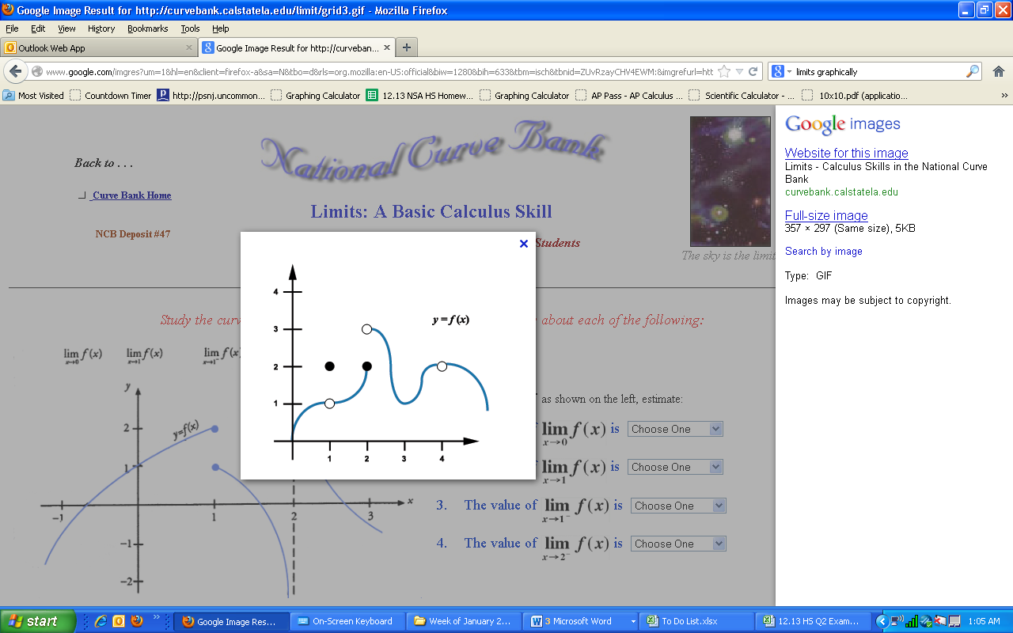

1. The graph of a function $f$ is shown above. For which of the following values of $c$ does $\lim_{x→c}{f(x)}=2$?
2. $1$ only
3. $4$ only
4. $1$ and $4$ only
5. $1, 2,$ and $4$

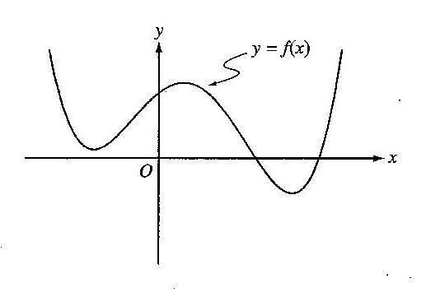

1. The graph of $f(x)$ is shown above. Which of the following could be the graph of $f^{'}\left(x\right)$?

|  |  |  |  |
| --- | --- | --- | --- |
| (A) |  | (B) |  |
| (C) |  | (D) |  |

1. The function $f$ is defined by $f\left(x\right)=\frac{x}{x+2}$. What points $\left(x, y\right)$ on the graph of $f$ have the property that the line tangent to $f$ at $(x, y)$ has slope $\frac{1}{2}$?
2. $(0, 0)$ only
3. $\left(\frac{1}{2},\frac{1}{5}\right)$ only
4. $\left(0, 0\right)$ and $\left(-4, 2\right)$
5. $\left(0, 0\right)$ and $\left(4,\frac{2}{3}\right)$
6. The function $f$ is twice differentiable with $f\left(4\right)=6$, $f^{'}\left(4\right)=3$, and $f^{''}\left(4\right)=2$. What is the value of the approximation of $f(3.9)$ using the line tangent to the graph of $f$ at $x=4$?

(A) $5.7$ (B) $5.8$ (C) $5.9$ (D) $6.2$

1. If $f^{'}\left(x\right)=x{\left(x-9\right)}^{2}(x+15)$, then $f$ has which of the following extrema?

I. A relative maximum at $x=-15$

II. A relative minimum at $x=0$

III. A relative maximum at $x=9$

(A) I only

(B) II only

(C) I and II

(D) I, II, and III

$\int{\frac{1}{x^{2}-6x+8}dx}$

$\frac{1}{2}\ln\left|\frac{x-4}{x-2}\right|+C$

$\frac{1}{2}\ln\left|\frac{x-2}{x-4}\right|+C$

$\frac{1}{2}\ln\left|\left(x-2\right)\left(x-4\right)\right|+C$

$\ln\left|x^{2}-6x+8\right|+C$

$\int_{1}^{4}{\left|x-3\right|}dx=$

(A) $-\frac{3}{2}$ (B) $\frac{3}{2}$ (C) $\frac{5}{2}$ (D) $\frac{9}{2}$

1. $\lim_{x→0}{\frac{x}{\cos{x}\sin{x}}}$ is

(A) $-1$ (B) $0$ (C) $1$ (D) nonexistent

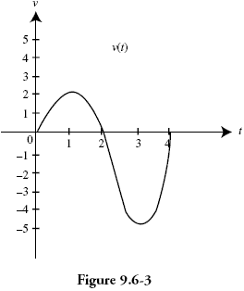

1. The velocity of a particle moving along the $x$-axis is shown above for $0<t<4$. The graph has horizontal tangents at $t=1$ and $t=3$, and a zero at $t=2$. For what values of $t$ is the speed of the particle decreasing?

(A) $1<t<3$ only

(B) $2<t<4$ only

(C) $0<t<1$ and $3<t<4$

(D) $1<t<2$ and $3<t<4$

1. If $y=x^{4}\tan{(3x)}$, then $\frac{dy}{dx}=$



$12x^{3}\sec^{2}\left(3x\right)$

$4x^{3}\tan{(3x)}+x^{4}\sec^{2}\left(3x\right)$

$x^{3}\left[4\tan\left(3x\right)+3x\sec^{2}\left(3x\right)\right]$

$x^{3}\left[x\tan\left(3x\right)+12\sec^{2}\left(3x\right)\right]$

6. If $f\left(x\right)=12xe^{x}$, on which of the following intervals is $f(x)$ concave down?



$\left(-∞, -2\right)$

$\left(-∞, -1\right)$

$\left(-1, +∞\right)$

$\left(-2, +∞\right)$

11. The graph of which of the following equations has $y=1$ as an asymptote?



$y=\ln{x}$

$y=\frac{2x}{x-1}$

$y=\frac{x^{2}}{x+1}$

$y=e^{-x}$

$\lim_{h→0}{\frac{\csc\left(\frac{3π}{4}+h\right)-\csc\left(\frac{3π}{4}\right)}{h}=}$

16. $-2$ (B) $-\sqrt{2}$ (C) $\sqrt{2}$ (D) $2$
17. For $t≥0$ hours, *H* is a differentiable function of *t* that gives the temperature, in degrees Celcius, at an arctic weather station. Which of the follow is the best interpretation of $H'(24)$?

(A) The change in temperature during the 24th hour.

(B) The average rate at which the temperature changed during the 24th hour.

(C) The rate at which the temperature is changing during the first day.

(D) The rate at which the temperature is changing at the end of the 24th hour.



$\lim_{x→∞}{\frac{(x-3)(2x-2)}{(6-x)(x-1)}}=$

(A) $-2$ (B) $-1$ (C) $0$ (D) $∞$

1. A particle moves along the $x$-axis with its position at time $t$ given by

$x\left(t\right)=(t-a)(t-b)$, where $a$ and $b$ are constants and $a≠b$. For which of the following values of $t$ is the particle at rest?

$t=ab$

$t=\frac{a+b}{2}$

$t=a+b$

4. $t=a$ and $t=b$

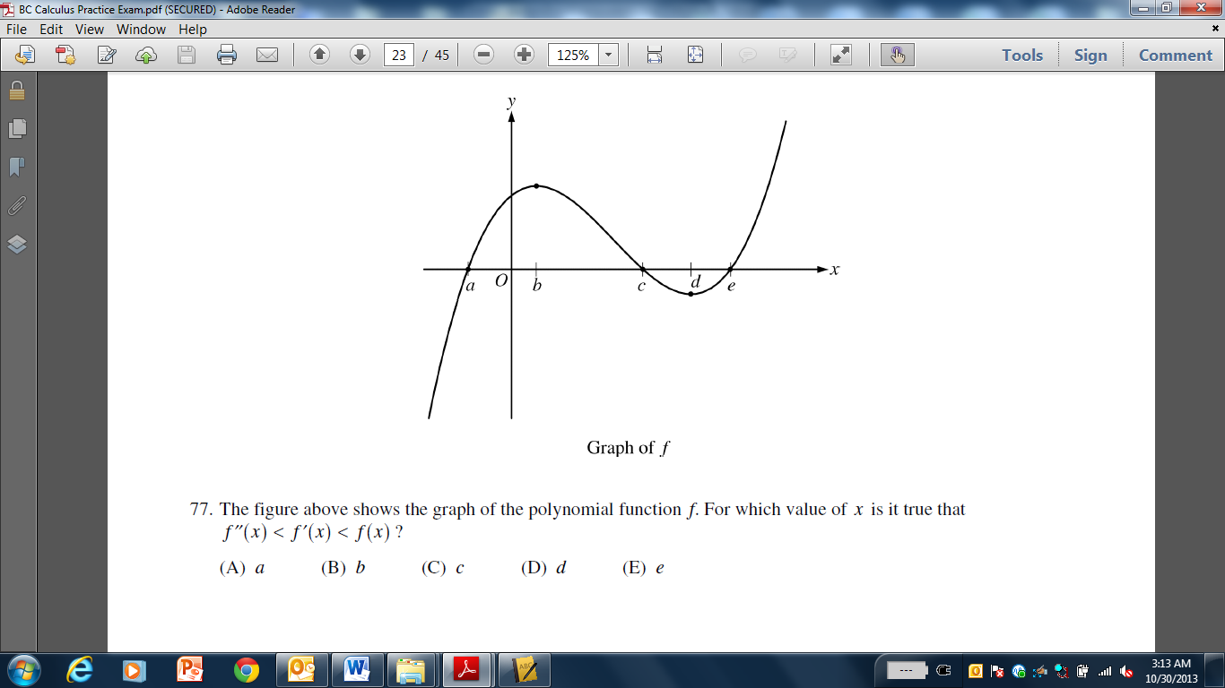

1. The figure above shows the graph of the polynomial function $f$. For which value of $x$ is it true that $f^{''}\left(x\right)<f^{'}\left(x\right)<f(x)$?



$a$

$b$

$c$

$d$

6. In the $xy$-plane, what is the slope of the line tangent to the graph of $x^{2}+xy+y^{2}=7$ at the point $(2, 1)$?
7. $-\frac{4}{3}$ (B) $-\frac{5}{4}$ (C) $-\frac{4}{5}$ (D) $-\frac{3}{4}$
8. Let $f$ be the function defined by $f\left(x\right)=2x^{3}-8x+6$. Which of the following is the equation of the line normal to the graph of $f$ at the point where $x=-1$?

(A) $y=-2x-2$

(B) $y=-2x+10$

(C) $y=\frac{1}{2}x+10$

(D) $y=\frac{1}{2}x+12.5$

1. If $f$ is differentiable at $x=a$, which of the following could be false?
2. $f$ is continuous at $x=a$.
3. $\lim_{x→a}{f(x)}$ exists.
4. $\lim_{x→a}{\frac{f\left(x\right)-f(a)}{x-a}}$ exists.
5. $\lim_{x→a}{\frac{f^{'}\left(x\right)-f^{'}(a)}{x-a}}$ exists
6. If $f\left(x\right)=x^{2}e^{x}$, then the absolute maximum value of $f$ on the closed interval $\left[-3,1\right]$ occurs when $x=$



$-3$

$-2$

$0$

$1$

11. Find a positive value, $c$, for $x$, that satisfies the conclusion of the Mean Value Theorem for Derivatives for $f\left(x\right)=3x^{2}-5x+1$ on the interval $\left[2,5\right]$.
12. $\frac{13}{6}$ (B) $\frac{11}{6}$ (C) $\frac{23}{6}$ (D) $\frac{7}{2}$
$\int_{0}^{3}{8x^{3}-2e^{x} dx}$

$108-2e^{3}$

$160-2e^{3}$

$162-2e^{3}$

$164-2e^{3}$

$$f\left(x\right)=\left\{\begin{aligned}\frac{x^{2}-4}{x-2} if x≠2 \\ 1 if x=2\end{aligned} \right.$$

14. Let $f$ be the function defined above. Which of the following statements about $f$ are true?
15. $f$ has a limit at $x=2$.
16. $f$ is continuous at $x=2$.
17. $f$ is differentiable at $x=2$.
18. I only
19. I and II only
20. I, II, and III
21. None

|  |  |  |  |  |
| --- | --- | --- | --- | --- |
| $$x$$ | -4 | -3 | -2 | -1 |
| $$f(x)$$ | 0.75 | -1.5 | -2.25 | -1.5 |
| $$f'(x)$$ | -3 | -1.5 | 0 | 1.5 |

1. The table above gives the values of a function $f$ and its derivative at selected values of $x$. If $f'$ is continuous on the interval $\left[-4,-1\right]$, what is the value of $\int_{-4}^{-1}{f^{'}\left(x\right)dx}$?
2. -4.5 (B) $-2.25$ (C) $0$ (D) 2.25
3. If $\frac{dy}{dx}=\cos{(2x)}$, then $y=$



$-2\sin\left(2x\right)+C$

$\frac{1}{2}\sin\left(2x\right)+C$

$\frac{1}{2}\sin^{2}\left(2x\right)+C$

$-\frac{1}{2}\sin\left(2x\right)+C$

8. Let $f\left(x\right)={\left(2x+1\right)}^{3}$ and let $g$ be the inverse function of $f$. Given that $f\left(0\right)=1$, what is the value of $g'(1)$?

$\frac{1}{54}$

$\frac{1}{27}$

$\frac{1}{6}$

$6$

$\int_{6}^{7}{\frac{2x^{2}-4x-14}{x-4}dx}$

(A) $\frac{5}{3}$ (B) $17+2\ln\left(\frac{2}{3}\right)$ (C) $17+2\ln\left(\frac{3}{2}\right)$ (D) $33+2\ln\left(\frac{2}{3}\right)$

|  |  |  |  |  |
| --- | --- | --- | --- | --- |
| $$x$$ | 2 | 5 | 7 | 8 |
| $$f(x)$$ | 10 | 30 | 40 | 20 |

1. The function $f$ is continuous on the closed interval $\left[2,8\right]$ and has values that are given in the table above. Using the subintervals $\left[2,5\right]$, $\left[5,7\right]$, and $\left[7,8\right]$, what is the trapezoidal approximation of $\int_{2}^{8}{f\left(x\right)dx}?$
2. 130 (B) 160 (C) 190 (D) 210

**END OF PART A**

**IF YOU FINISH BEFORE TIME IS CALLED,**

**YOU MAY CHECK YOUR WORK ON PART A ONLY.**

**DO NOT GO ON TO PART B UNTIL YOU ARE TOLD TO DO SO**